AWS THREE TIER ARCHITECTURE BY TERRAFORM
- A Three tier Architecture is a well-structured way to build scalable, secure, and manageable applications by dividing them into three layers.

- Web-Tier (Frontend): The Web tier is the user interface and communication layer of the application, where the end user interacts with the application. Its main purpose is to display information to and collect information from the user. This top-level tier can run on a web browser, as desktop application, or a graphical user interface (GUI). Web presentation tiers are developed by using HTML, CSS, and JavaScript. Desktop applications can be written in various languages depending on the platform.

- Application-Tier (Business Logic): The application tier, also known as the logic tier or middle tier, is the heart of the application. The application tier is typically developed by using Python, Java, Perl, PHP or Ruby, and communicates with the data tier by using API calls.

- Data-Tier (Data Storage): The data tier, sometimes called database tier, data access tier or back-end, is where the information that is processed by the application is stored and managed. This can be a relational database management system as PostgresSQL, MySQL,MariaDB.

- In this Three-tier architecture project we have used several AWS services and resources which has been illustrated by below architecture.
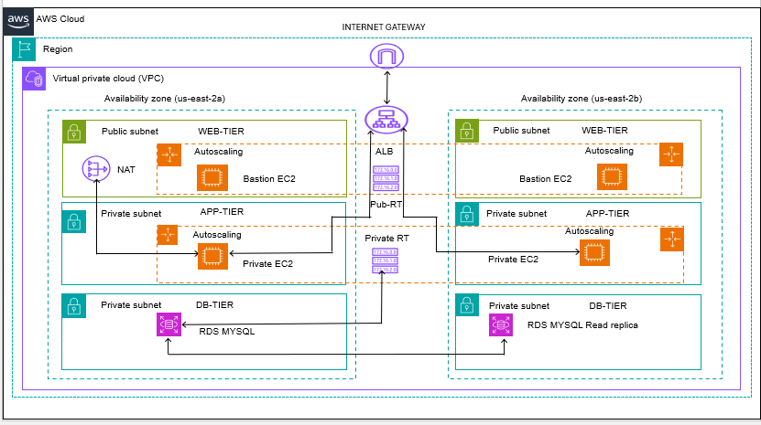
EXPLANATION
- In AWS cloud and Ohio (us-east-2) region we have created Virtual private network (VPC) and Internet gateway and have attached to the created VPC.
- After creation of VPC, we have created two public subnets and two private subnets with public Route table and private Route table.
- Created a Nat gateway in the public subnet so that EC2 instances in private subnet will be able to access internet.
- Configure the Public Route Table and Private Route Table and associate the subnets accordingly.
- Created an application load balancer which will be able to distribute traffic among the healthy private instance by using autoscaling service to ensure high scalability and high available.
- The information processed by application will be stored in Database tier in private subnet which ensures security and at the same time the read replicas will be also used to offload read related queries that makes primary DB instance work more efficiently.
STEP 1: We are going to deploy the AWS 3 tier architecture by using terraform scripts.Here we have deployed the 3 tier architecture by modules concept of Terraform.Below are the terraform scripts of the AWS resources which have been used to deploy 3 tier architecture.
# Provider Block

terraform {
required_providers {
aws = {
source= "hashicorp/aws"
}
}
}

provider "aws"{
region = "us-east-2"
}

# VPC, SUBNETS, ROUTE TABLE, NAT ,IGW

resource "aws_vpc" "projectvpc" {
cidr_block = "10.0.0.0/16"
tags = {
Name = "projectvpc"
}
}

resource "aws_subnet" "public-subnet-1" {
vpc_id = aws_vpc.projectvpc.id
cidr_block = "10.0.1.0/24"
availability_zone = "us-east-2a"
map_public_ip_on_launch = true
tags = {
Name = "Public-subnet-1"
}
}

resource "aws_subnet" "public-subnet-2" {
vpc_id = aws_vpc.projectvpc.id
cidr_block = "10.0.2.0/24"
availability_zone = "us-east-2b"
map_public_ip_on_launch = true
depends_on = [ aws_subnet.public-subnet-1 ]
tags = {
Name = "Public-subnet-2"
}
}

resource "aws_subnet" "private-subnet-1" {
vpc_id = aws_vpc.projectvpc.id
cidr_block = "10.0.3.0/24"
availability_zone = "us-east-2a"
depends_on = [ aws_subnet.public-subnet-2 ]
tags = {
Name = "Private-subnet-1"
}
}

resource "aws_subnet" "private-subnet-2" {
vpc_id = aws_vpc.projectvpc.id
cidr_block = "10.0.4.0/24"
availability_zone = "us-east-2b"
depends_on = [ aws_subnet.private-subnet-1 ]
tags = {
Name = "Private-subnet-2"
}
}

resource "aws_internet_gateway" "project-igw" {
vpc_id = aws_vpc.projectvpc.id
depends_on = [ aws_vpc.projectvpc ]
}

resource "aws_route_table" "public-route-table" {
vpc_id = aws_vpc.projectvpc.id
depends_on = [ aws_subnet.public-subnet-2 ]
}

resource "aws_route" "public-internet-access" {
route_table_id = aws_route_table.public-route-table.id
destination_cidr_block = "0.0.0.0/0"
gateway_id = aws_internet_gateway.project-igw.id
depends_on = [ aws_route_table.public-route-table ]
}

resource "aws_route_table" "private-route-table" {
vpc_id = aws_vpc.projectvpc.id
depends_on = [ aws_route.public-internet-access]
}

resource "aws_eip" "nat" {
domain = "vpc"
tags = {
Name = "nat-eip"
}
}

resource "aws_nat_gateway" "project-NAT" {
allocation_id = aws_eip.nat.id
subnet_id = aws_subnet.public-subnet-1.id
tags = {
Name = "Project-NAT"
}
}

resource "aws_route_table_association" "public-subnet-associataion" {
subnet_id = aws_subnet.public-subnet-1.id
route_table_id = aws_route_table.public-route-table.id
}

resource "aws_route_table_association" "public-subnet2-associataion" {
subnet_id = aws_subnet.public-subnet-2.id
route_table_id = aws_route_table.public-route-table.id
}

resource "aws_route_table_association" "private-subnet-associataion" {
subnet_id = aws_subnet.private-subnet-1.id
route_table_id = aws_route_table.private-route-table.id
}

resource "aws_route_table_association" "private-subnet1-associataion" {
subnet_id = aws_subnet.private-subnet-2.id
route_table_id = aws_route_table.private-route-table.id
}

#EC2 WEB TIER AND APP-TIER

resource "aws_instance" "example" {
ami = var.instance_ami
instance_type = var.instance_type
key_name = var.key_name
subnet_id = aws_subnet.public-subnet-1.id
tags = {
Name = "Bastion-EC2"
}
}

resource "aws_instance" "example1" {
ami = var.instance_ami
instance_type = var.instance_type
key_name = var.key_name
subnet_id = aws_subnet.private-subnet-1.id
tags = {
Name = "Private-EC2"
}
}

# ALB ,TARGET GROUPS AND LISTENER

resource "aws_lb" "alb" {
name = "app-load-balancer"
internal = false
load_balancer_type = "application"
subnets = [aws_subnet.public-subnet-1.id, aws_subnet.public-subnet-2.id]
}

resource "aws_lb_target_group" "my-TG" {
name = "my-target-group"
port = 8080
protocol = "HTTP"
vpc_id = aws_vpc.projectvpc.id
}

resource "aws_lb_listener" "http_listener" {
load_balancer_arn = aws_lb.alb.arn
port = 80
protocol = "HTTP"

default_action {
type = "forward"
target_group_arn = aws_lb_target_group.my-TG.arn
}
}

resource "aws_launch_template" "my_launch" {
name = "my-launch"
instance_type = var.instance_type
key_name = var.key_name
image_id = var.instance_ami
}

resource "aws_autoscaling_group" "myauto" {
min_size = 1
max_size = 2
vpc_zone_identifier = [aws_subnet.public-subnet-1.id, aws_subnet.public-subnet-2.id]

launch_template {
id = aws_launch_template.my_launch.id
version = "$Latest"
}
}

# Security Group for Bastion EC2 ,Private EC2 ,ALB and DB

resource "aws_security_group" "ALBSG" {
name = "yash-alb-sg"
description = "External load balancer security group"
vpc_id = aws_vpc.projectvpc.id
tags = {
Name = "yash-SG"
Created_BY = "yash"
Project = "terraform"
}

# Inbound rules
ingress {
description = "Allow http"
from_port = 80
to_port = 80
protocol = "tcp"
cidr_blocks = ["0.0.0.0/0"] # Allow from anywhere
}

ingress {
description = "Allow Tomcat"
from_port = 8080
to_port = 8080
protocol = "tcp"
cidr_blocks = ["0.0.0.0/0"] # Allow from anywhere
}

# Outbound rule allowing all traffic
egress {
from_port = 0
to_port = 0
protocol = "-1"
cidr_blocks = ["0.0.0.0/0"]
}
}

resource "aws_security_group" "BastionSG" {
name = "yash-Bastion-SG"
description = "web tier security group"
vpc_id = aws_vpc.projectvpc.id

ingress {
description = "Allow ssh"
from_port = 22
to_port = 22
protocol = "tcp"
cidr_blocks = ["0.0.0.0/0"] # Allow from anywhere
}
ingress {
from_port = 80
to_port = 80
protocol = "tcp"
cidr_blocks = ["0.0.0.0/0"]
}

egress {
from_port = 0
to_port = 0
protocol = "-1"
cidr_blocks = ["0.0.0.0/0"]
}

tags = {
Name = "yash-Bastion-SG"
Created_BY = "yash"
Project = "terraform"
}
}

resource "aws_security_group" "db-sg" {
vpc_id = aws_vpc.projectvpc.id
name = "db-sg"
tags = {
Name = "db-sg"
}

ingress {
from_port = 3306
to_port = 3306
protocol = "tcp"
cidr_blocks = ["10.0.3.0/24", "10.0.4.0/24"]
# Allow traffic from private subnets
}

egress {
from_port = 0
to_port = 0
protocol = "-1"
cidr_blocks = ["0.0.0.0/0"]
}
}

resource "aws_security_group" "app-tier" {
name = "app-tier-SG"
description = "private-instance-sg"
vpc_id = aws_vpc.projectvpc.id
tags = {
Name = "app-tier-SG"
}
ingress {
from_port = 22
to_port = 22
protocol = "tcp"
security_groups = [aws_security_group.BastionSG.id]
}

ingress {
from_port = 8080
to_port = 8080
protocol = "tcp"
security_groups = [aws_security_group.ALBSG.id] # Only Bastion can access
}
egress {
from_port = 0
to_port = 0
protocol = "-1"
cidr_blocks = ["0.0.0.0/0"]
}
}

# DB TIER

resource "aws_db_instance" "myrds" {
identifier = "projectrds"
instance_class = var.db_instance_class
engine = var.engine
engine_version = var.engine_version
allocated_storage = var.allocated_storage
username = var.username
password = var.password
db_name = var.db_name
skip_final_snapshot = true
multi_az = false
publicly_accessible = false
db_subnet_group_name = aws_db_subnet_group.db_subnet.id
backup_retention_period = 7
tags = {
Name = "yashdb"
Created_BY = "yash"
}
}

resource "aws_db_instance" "rdsreplica1" {
replicate_source_db = aws_db_instance.myrds.identifier
instance_class = var.db_instance_class
skip_final_snapshot = true
publicly_accessible = false
depends_on = [aws_db_instance.myrds]
}

resource "aws_db_subnet_group" "db_subnet" {
name = "db-subnet-group"
subnet_ids = [aws_subnet.private-subnet-1.id, aws_subnet.private-subnet-2.id]
}

# variable.tf file for all resources

variable "instance_ami" {
description = "ami for all ec2-instances"

}

variable "instance_type" {
description = "instance type for ec2"

}

variable "key_name" {
description = "keyname for ec2"
}

variable "db_name" {
description = "db name for ec2-instance"

}

variable "username" {
description = "username for db"

}

variable "password" {
description = "password for db"

}

variable "db_instance_class" {
description = "instance-class"
}

variable "engine" {
}

variable "engine_version" {
}

variable "allocated_storage" {

}

# main.tf file which will resue the configuration of the resources for the Project

provider "aws" {
region = "us-east-2"
}

terraform {
backend "s3" {
bucket = "yashubkt6328"
region = "us-east-2"
key = "yashu/terraform.tfstate"
}
}

module "project" {
source = "./modules"
instance_ami = "ami-08c65a248ce71fb2d"
instance_type = "t2.micro"
key_name = "ohio"
db_name = "shoppingcart"
username = "admin"
password = "root12345"
db_instance_class = "db.t3.micro"
engine = "mysql"
engine_version = "8.0"
allocated_storage = 20
}

STEP 2: We have to initialize terraform by terraform init command as shown in below.After terraform plan and terraform apply command we can verify that the resouces has been deployed in AWS envirnoment.
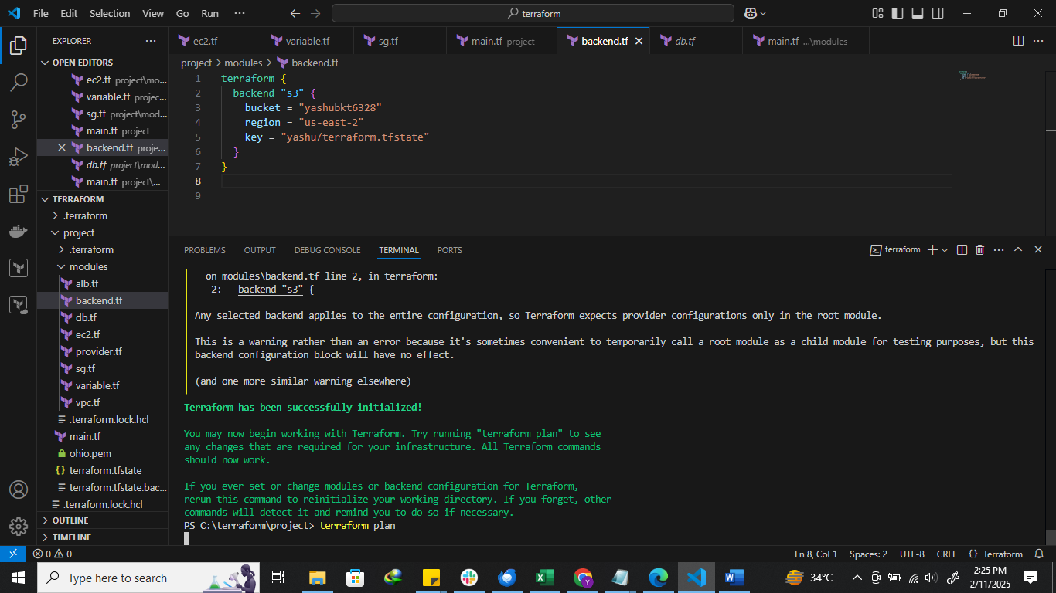

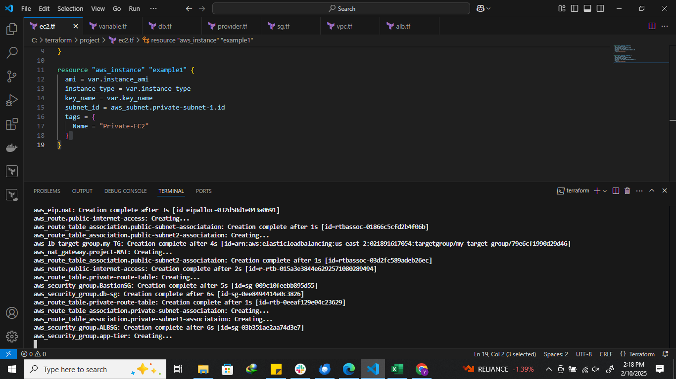

STEP 3: In the following below references we can verify that the resources are being deploy on AWS platform.
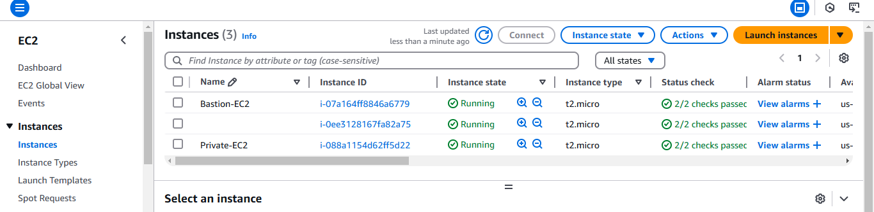

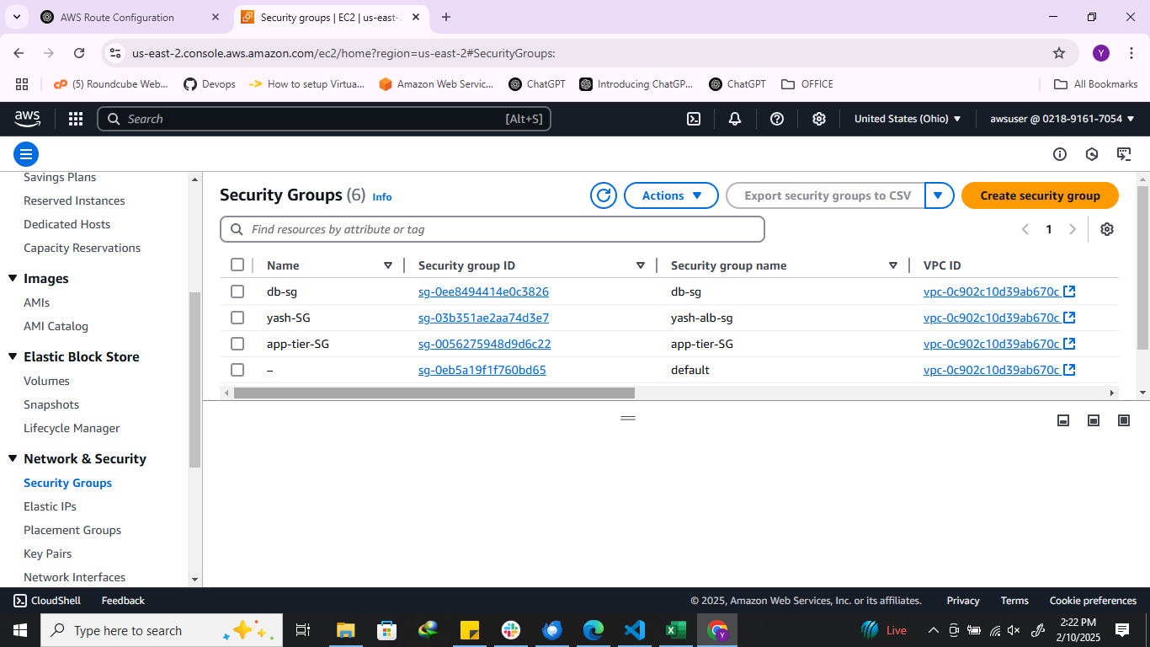

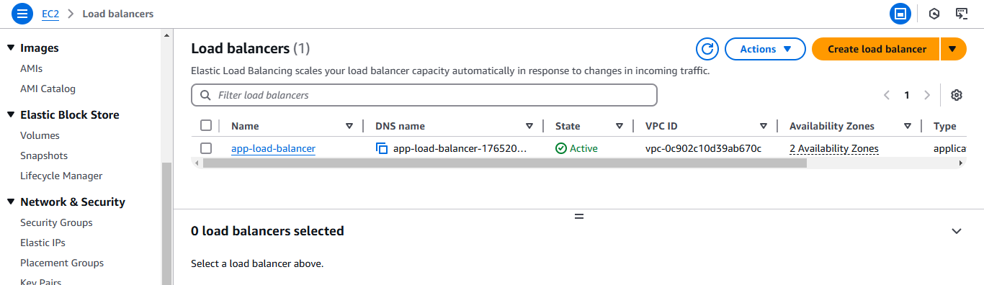
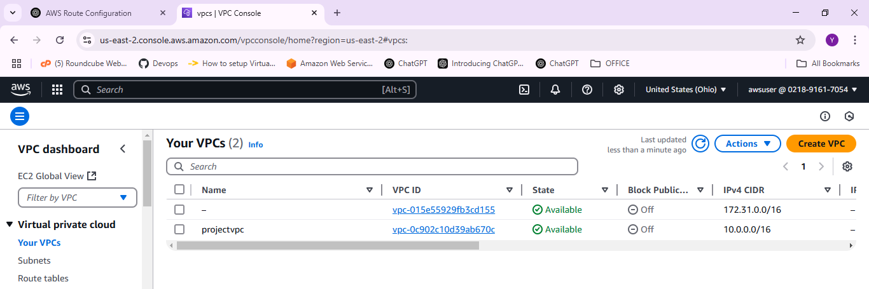

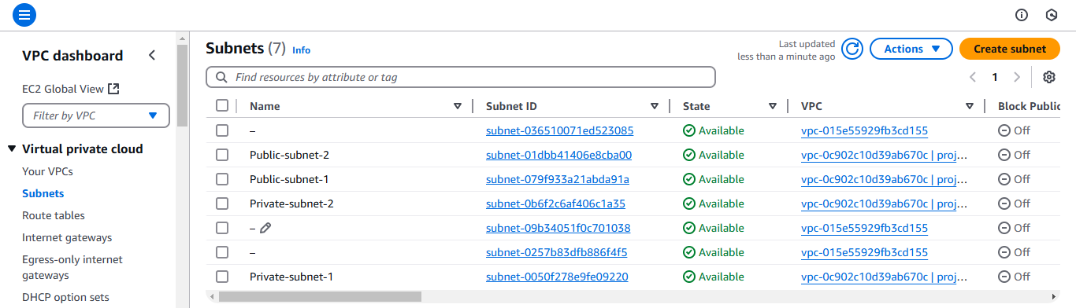
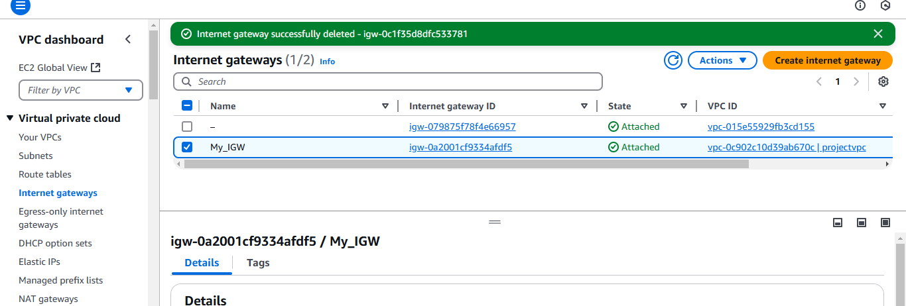

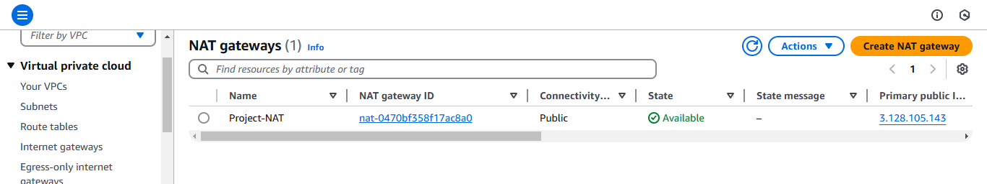

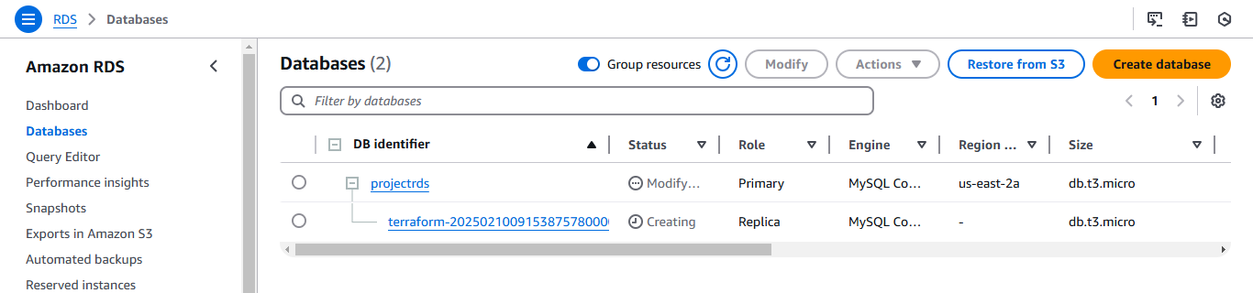
STEP 4: As we have used the AMI of previous task (manual task) where application has been already deployed .After doing Database configurations we can access the application by the Load Balancer DNS name.
